“Service you deserve,
Expertise you need!”
Conduct business with confidence with Strategic Management and services.

Who We are
AFIML is an organization with the mission to develop IT strategic infrastructure for effective banking systems in India and to take them to the next level by developing every aspect of business as strategy, technology, and funds together.
In our legacy of the organization, we have developed the strategic Infrastructure for Banking in India, with the most unique and innovative process, product, and technology to redefine the banking and economy generation modules together. Our R&D, Processes, technology teams are tremendously doing their jobs to impact industry, even though a lot of acknowledgements have been received on the same.

Objective & Innovations
To develop strategic infrastructure for effective banking systems in India and to take them to the next level by developing every aspect of business as strategy, technology, and funds together.
Zero Pendency System
| Measure the potential of your workforce with one click

Zero Pendency System Simply put, with the latest and unique feature of Target vs Achievement, each team member sets tailored and realistic targets for employees. This feature enables managers to monitor individual or team performance in real-time and measure performance metrics. Based on the results/outcome, organizations can implement corrective actions, revise their policies, or train underperforming employees.

Managers can now get real-time information about how each employee is performing their duties.
Then, based on the results, they can take immediate corrective measures if needed. For example, if a manager realizes that some of his employees are falling short of their targets, They can identify the cause of the problem and fix it as soon as possible. At the same time, the manager can share the modus operandi or approach of the employees who have excelled and achieved the goals with the rest of the team. Overall, this feature will help organizations increase overall productivity by identifying low-productive employees and ultimately providing them with appropriate training and guidance.

What are the main advantages of zero Pendency System?
Provides many benefits to managers as well as the organization. This feature has three most important advantages:
1. Allows you to create employee-specific goals.
2. Let’s you do real-time performance evaluation
3. Helps identify errors in strategy or workflow.

Let's understand how?
1. Allows you to create employee-specific goals.
With this feature, you can set personalized targets for each employee. This allows you to set different goals for new and experienced employees, ensuring that each employee is allocated work based on their experience and competence.

2. Let’s you do real-time performance evaluation
The Zero Pendency System feature helps you track individual or team performance in real-time.

3. Helps identify errors in strategy or workflow.
Zero Pendency System's real-time data and reporting analysis will allow you to identify and fill gaps in your approach.
For example, you can determine if your employees need any specific training or if workflows need to be overhauled.

What metrics can be measured using the Zero Pendency System feature?

Unique Zero Pendency System Target Vs. Achievements feature allows you to track and measure various metrics such as targets. Moreover, you can define individual targets for each employee and edit them as needed.

For example, for senior employees, you can set 10 calls per day, at the end of the month, or after a period, you can extract the data and assess whether the employees met their respective targets.

If you find that many employees have met their targets, you can increase their targets for the following month. For underperforming employees, you can arrange training and counseling programs to improve their performance.

Technology Snapshot
- Log in
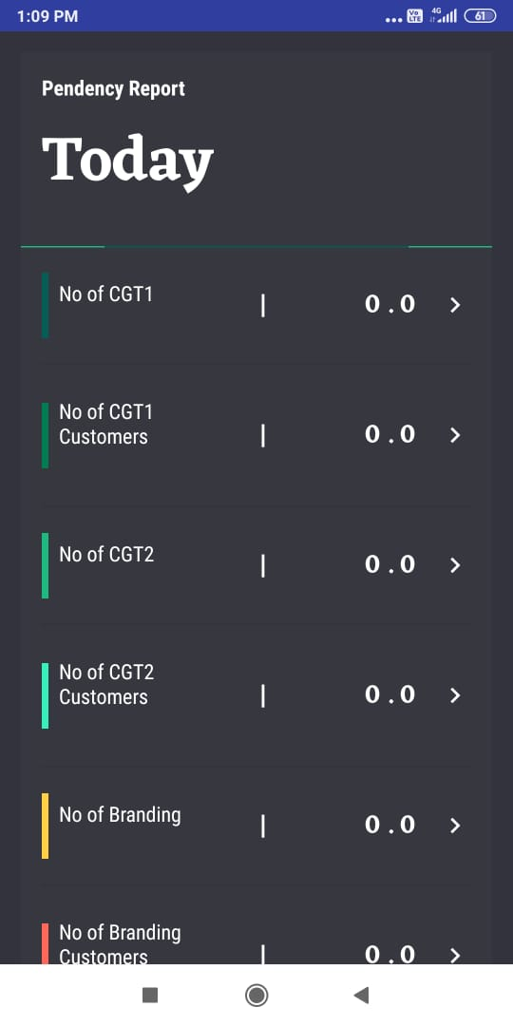
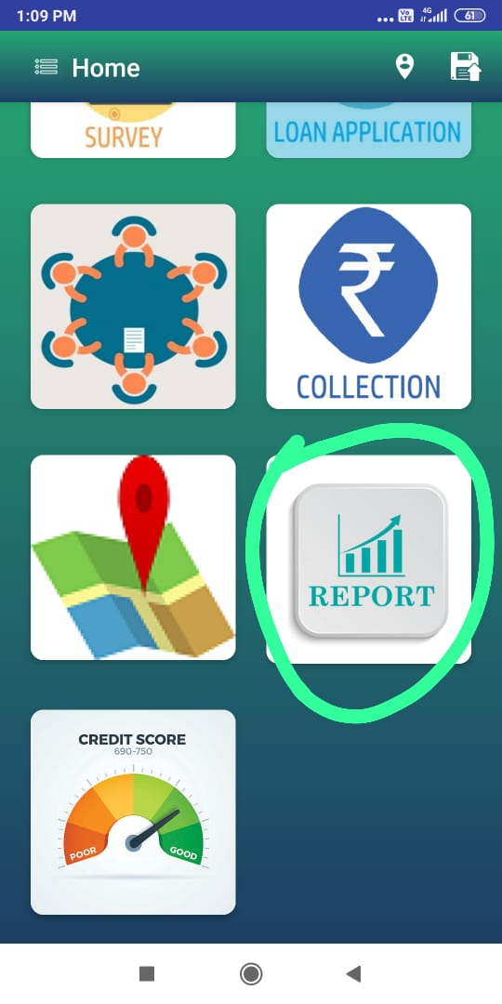
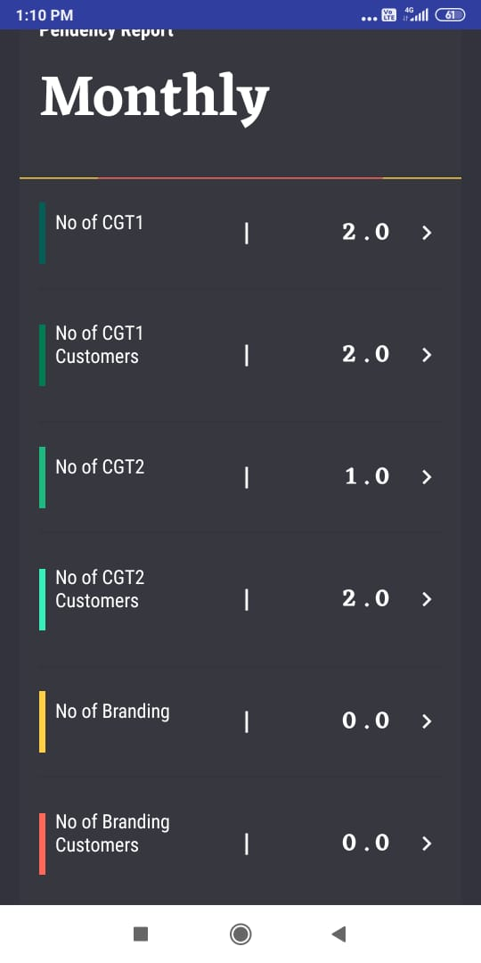
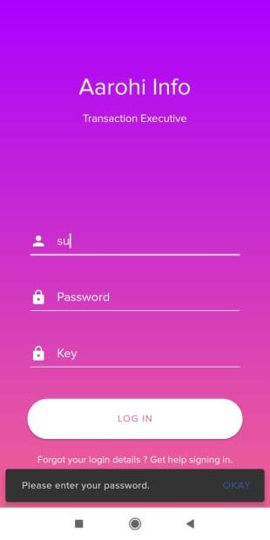
4 . Monthly Performance
3 . Daily Performance
2. Select Report

4 . Overall Performance

